**Market Research & Use Case Generation Agent Documentation**

**Overview**

The **Market Research & Use Case Generation Agent** is a multi-agent system designed to generate relevant AI and Generative AI (GenAI) use cases tailored to a specified company or industry. By leveraging market research, the system identifies industry trends, analyses a company's offerings, and proposes actionable AI solutions to enhance operations and customer experiences.

**Features**

1. **Industry Research**: Utilizes web scraping to gather information about the industry and the company, including key offerings and strategic focus areas.
2. **Use Case Generation**: Analyses industry standards and trends related to AI, ML, and automation, proposing relevant use cases to leverage GenAI and ML technologies.
3. **Resource Asset Collection**: Gathers relevant datasets and resources from platforms like Kaggle, Hugging Face, and GitHub, providing links for easy access.
4. **Comprehensive Reporting**: Generates a detailed report summarizing the findings, use cases, and resource links.

**Code Explanation**

* The required libraries are imported, including crewai for multi-agent operations, os and dotenv for environment variable management, and langchain for integrating OpenAI's language model.

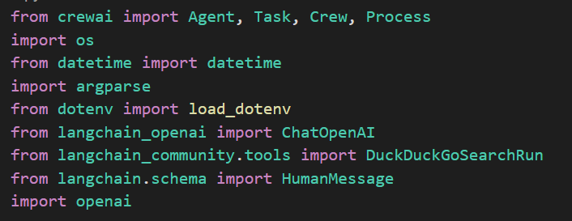

* The OpenAI API key is loaded from environment variables.



* An instance of the OpenAI Chat model is created, setting parameters for response variability and maximum token count.

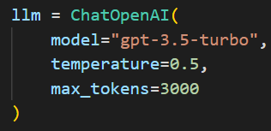

* The MarketResearchCrew class initializes three agents responsible for researching the industry, generating use cases, and collecting resources.

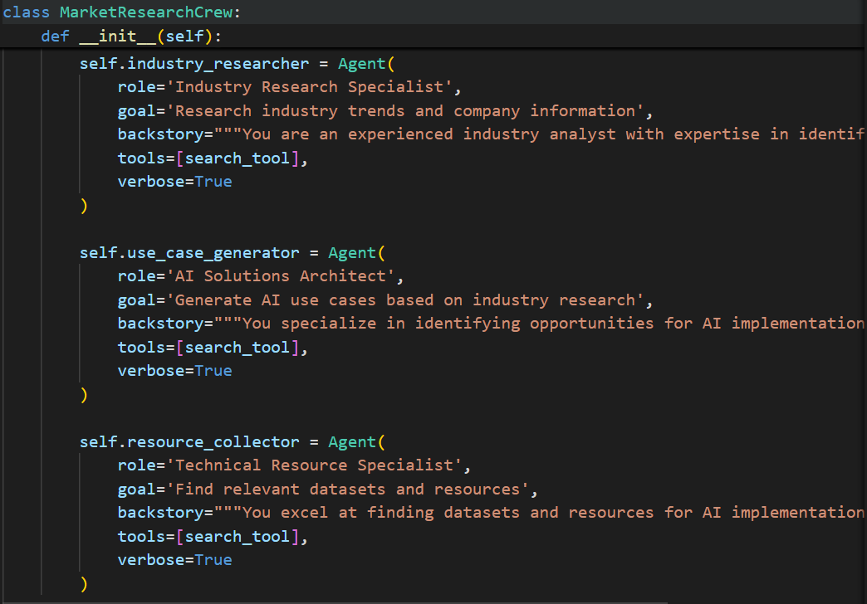

* The research_company method creates three tasks for the crew:

1. Research Task: To gather information about the company and its industry.
2. Use Case Task: To generate AI use cases based on the research.
3. Resource Task: To collect relevant datasets and resources for the proposed use cases.

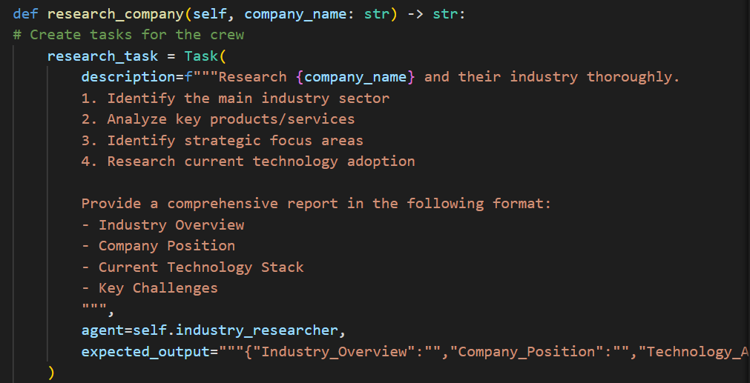

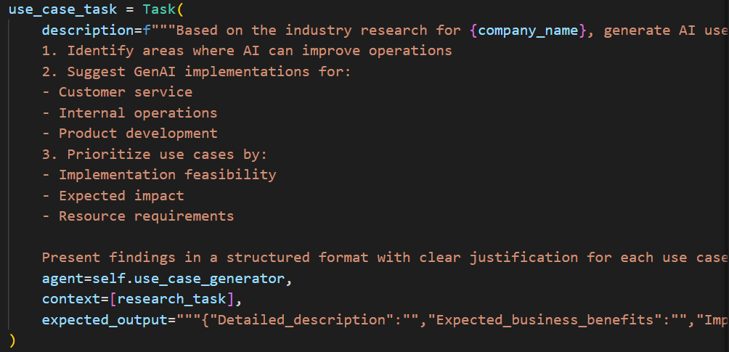

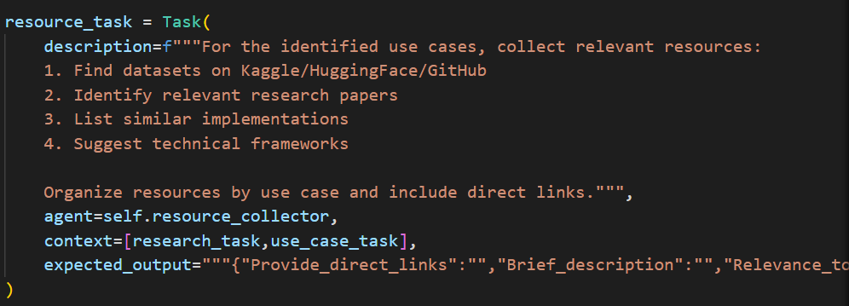

* A crew is created with the defined agents and tasks, and the process is executed sequentially. The results of the execution are collected for further processing.

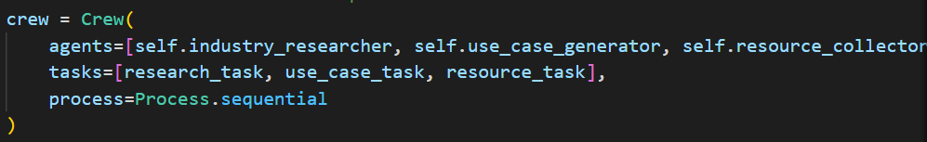

* The aggregate_results method formats the results collected from all agents into a single string for easier reporting

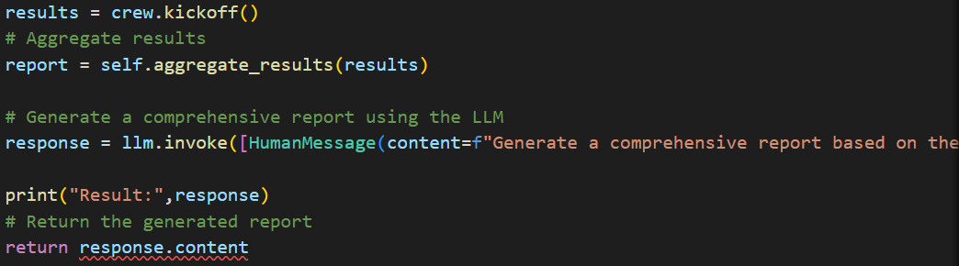.

* This function saves the generated report to a Markdown file with a timestamped filename, allowing for easy reference and organization.
* The main function sets up command-line argument parsing, initializes the MarketResearchCrew, and invokes the company research process. It then saves the results to a file and informs the user of completion.

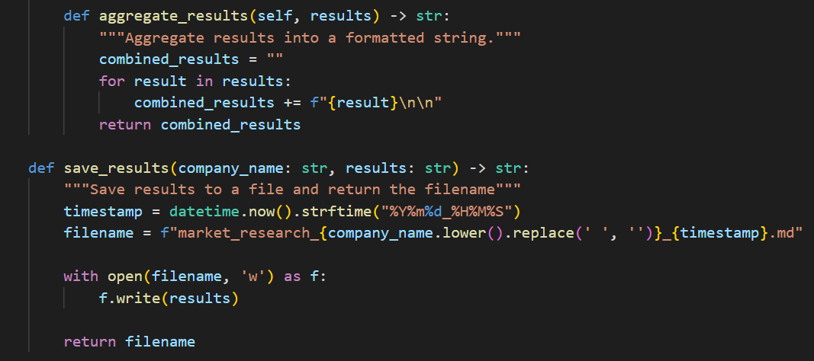

**Output**

Upon execution, the system will conduct market research, generate AI use cases, collect resource assets, and save the results in a markdown file named market_research_<company_name>_<timestamp>.md in the current directory.

**Architecture Overview**

The architecture of the **Market Research & Use Case Generation Agent** consists of three primary agents:

1. **Industry Research Specialist**:
   * Conducts comprehensive research on the specified company and its industry.
   * Collects information about the main industry sector, key products/services, strategic focus areas, current technology stack, and market trends.
2. **AI Solutions Architect**:
   * Generates use cases based on the insights gained from industry research.
   * Identifies opportunities for AI implementation across various operational aspects, including customer service and product development.
   * Prioritizes use cases based on feasibility, impact, and resource requirements.
3. **Technical Resource Specialist**:
   * Searches for relevant datasets and resources to support the proposed use cases.
   * Compiles a list of datasets from platforms like Kaggle, HuggingFace, and GitHub, along with relevant research papers and implementations.

**Flowchart:**

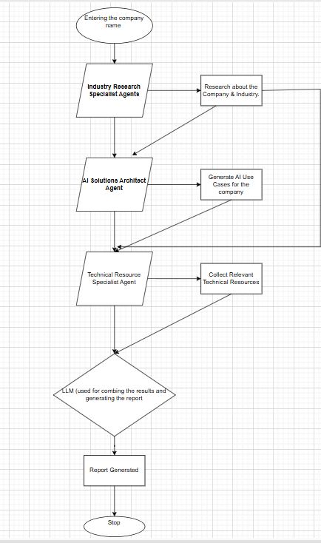

**Methodology**

1. **Research Phase**: The **Industry Research Specialist** agent performs a detailed analysis of the company and industry.
2. **Use Case Development**: The **AI Solutions Architect** generates a list of AI use cases based on research findings.
3. **Resource Collection**: The **Technical Resource Specialist** collects relevant datasets and resources to support implementation.
4. **Reporting**: All results are aggregated and summarized into a comprehensive report using the **ChatOpenAI** model.

**Conclusion**

The **Market Research & Use Case Generation Agent** effectively combines multi-agent architecture with advanced AI capabilities to provide valuable insights and actionable use cases for organizations looking to leverage AI and Generative AI technologies. By automating market research and resource collection, this system streamlines the process of identifying and implementing AI solutions, enhancing operational efficiency and customer satisfaction.